**A**

***PROJECT REPORT***

*on*

***Swaad-Saathi: Food Delivery System***

*Submitted in partial fulfilment of the requirements for the degree of*

**BACHELOR OF TECHNOLOGY**



Session: - 2024

Submitted by

Daksh Sharma (20ETCCS024)

Dikshant Dak(20ETCCS034)

Paramveer Rathore (20ETCCS082)

Dhruv Paliwal (20ETCCS033)

Lakshya Khandelwal (20ETCCS067)

Jainam Jain (20ETCCS056)

Under Guidance of

Mr. Aaditya Maheshwari

Assistant Professor

Dept. of CSE TINJRIT, Udaipur

**DEPARTMENT OF COMPUTER SCIENCE AND ENGINEERING**

**TECHNO INDIA NJR INSTITUTE OF TECHNOLOGY, UDAIPUR-313001**

**2024**

**A**

***PROJECT REPORT***

*On*

**Swaad-Saathi: Food Delivery System**

*Submitted in partial fulfilment of the requirements for the degree of*

**BACHELOR OF TECHNOLOGY**



**Session: - 2024**

Submitted by

Daksh Sharma (20ETCCS024)

Dikshant Dak(20ETCCS034)

Paramveer Rathore (20ETCCS082)

Dhruv Paliwal (20ETCCS033)

Lakshya Khandelwal (20ETCCS067)

Jainam Jain (20ETCCS056)

8th Sem (CSE)

Under Guidance of

Mr. Aaditya Maheshwari

Assistant Professor

Dept. of CSE TINJRIT, Udaipur

**DEPARTMENT OF COMPUTER SCIENCE AND ENGINEERING**

**TECHNO INDIA NJR INSTITUTE OF TECHNOLOGY, UDAIPUR-313001**

**2024**



Department of Computer Science and Engineering

Techno India NJR Institute of Technology, Udaipur-313001

**Certificate**

This is to certify that project work titled **Swaad-Saathi** by **Daksh Sharma** was successfully carried out in the Department of Computer Science and Engineering, TINJRIT and the report is approved for submission in the partial fulfillment of the requirements for award of degree of Bachelor of Technology in Computer Science and Engineering.

Mr. Aaditya Maheshwari Dr. Rimpy Bishnoi

Assistant Professor Head of Department

Dept. of CSE TINJRIT, Udaipur Dept. of CSE TINJRIT, Udaipur

Date Date



Department of Computer Science and Engineering

Techno India NJR Institute of Technology, Udaipur-313001

**Certificate**

This is to certify that project work titled **Swaad-Saathi** by **Dikshant Dak** was successfully carried out in the Department of Computer Science and Engineering, TINJRIT and the report is approved for submission in the partial fulfillment of the requirements for award of degree of Bachelor of Technology in Computer Science and Engineering.

Mr. Aaditya Maheshwari Dr. Rimpy Bishnoi

Assistant Professor Head of Department

Dept. of CSE TINJRIT, Udaipur Dept. of CSE TINJRIT, Udaipur

Date Date



Department of Computer Science and Engineering

Techno India NJR Institute of Technology, Udaipur-313001

**Certificate**

This is to certify that project work titled **Swaad-Saathi** by **Dhruv Paliwal** was successfully carried out in the Department of Computer Science and Engineering, TINJRIT and the report is approved for submission in the partial fulfillment of the requirements for award of degree of Bachelor of Technology in Computer Science and Engineering.

Mr. Aaditya Maheshwari Dr. Rimpy Bishnoi

Assistant Professor Head of Department

Dept. of CSE TINJRIT, Udaipur Dept. of CSE TINJRIT, Udaipur

Date Date



Department of Computer Science and Engineering

Techno India NJR Institute of Technology, Udaipur-313001

**Certificate**

This is to certify that project work titled **Swaad-Saathi** by **Paramveer Singh Rathore** was successfully carried out in the Department of Computer Science and Engineering, TINJRIT and the report is approved for submission in the partial fulfillment of the requirements for award of degree of Bachelor of Technology in Computer Science and Engineering.

Mr. Aaditya Maheshwari Dr. Rimpy Bishnoi

Assistant Professor Head of Department

Dept. of CSE TINJRIT, Udaipur Dept. of CSE TINJRIT, Udaipur

Date Date



Department of Computer Science and Engineering

Techno India NJR Institute of Technology, Udaipur-313001

**Certificate**

This is to certify that project work titled **Swaad-Saathi** by **Lakshya Khandelwal** was successfully carried out in the Department of Computer Science and Engineering, TINJRIT and the report is approved for submission in the partial fulfillment of the requirements for award of degree of Bachelor of Technology in Computer Science and Engineering.

Mr. Aaditya Maheshwari Dr. Rimpy Bishnoi

Assistant Professor Head of Department

Dept. of CSE TINJRIT, Udaipur Dept. of CSE TINJRIT, Udaipur

Date Date



Department of Computer Science and Engineering

Techno India NJR Institute of Technology, Udaipur-313001

**Certificate**

This is to certify that project work titled **Swaad-Saathi** by **Jainam Jain** was successfully carried out in the Department of Computer Science and Engineering, TINJRIT and the report is approved for submission in the partial fulfillment of the requirements for award of degree of Bachelor of Technology in Computer Science and Engineering.

Mr. Aaditya Maheshwari Dr. Rimpy Bishnoi

Assistant Professor Head of Department

Dept. of CSE TINJRIT, Udaipur Dept. of CSE TINJRIT, Udaipur

Date Date

**Examiner Certificate**

This is to certify that the following student

**Daksh Sharma, Dikshant Dak, Dhruv Paliwal, Paramveer Singh Rathore, Lakshya Khandelwal and Jainam Jain** of final year B.Tech. (Computer Science and Engineering), was examined for the project work titled

***Swaad-Saathi: A Food Delivery System***

during the academic year 2023 – 2024 at Techno India NJR Institute of Technology, Udaipur

**Remarks:**

**Date:**

Signature Signature

(**Internal Examiner**) (**External Examiner**)

Name :- Name :-

Designation:- Designation:-

Department: - Department: -

Organization:- Organization:-

**ACKNOWLEDGMENT**

We take this opportunity to record our sincere thanks to all who helped us to successfully complete this work. Firstly, We are grateful to our **supervisor Mr. Aaditya Maheshwari.**

for his invaluable guidance and constant encouragement, support and most importantly for giving us the opportunity to carry out this work.

We would like to express our deepest sense of gratitude and humble regards to our

**Head of Department Dr. Rimpy Bishnoi** for giving invariable encouragement in our endeavors and providing necessary facility for the same. Also, a sincere thanks to all faculty members of CSE, TINJRIT for their help in the project directly or indirectly.

Finally, we would like to thank my friends for their support and discussions that have proved very valuable for us. We are indebted to our parents for providing constant support, love and encouragement. We thank them for the sacrifices they made so that we could grow up in a learning environment. They have always stood by us in everything we have done, providing constant support, encouragement and love

**Daksh Sharma (20ETCSS024)**

**Dikshant Dak (20ETCCS034)**

**Paramveer Singh Rathore (20ETCCS082)**

**Dhruv Paliwal (20ETCCS033)**

**Lakshya Khandelwal (20ETCCS067)**

**Jainam Jain(20ETCCS056)**

DEPARTMENT OF COMPUTER SCIENCE AND ENGINEERING

TECHNO INDIA NJR INSTITUTE OF TECHNOLOGY, UDAIPUR-313001

**CONTENTS**

|  |  |
| --- | --- |
| **Name of Contents** | **Page no.** |
| Certificate 1 | 3-8 |
| Certificate 2 | 9 |
| Acknowledgements | 10 |
| Contents | 11 |
| List of Figures | 12 |
| Chapter 1: Introduction   * 1. Title of Project   2. Objective of the Project   3. Technology Used   4. Technology Advantages and Disadvantages | 13  13  14  15  16 |
| Chapter 2: Implementation  2.1 Step 1: Registration & Login  2.2 Step 2: Home  2.3 Step 3: Restaurants  2.3.a: Add to cart  2.3.b: Order now   * 1. Step 4: Profile   2. Step 5: Orders   3. Step 6: Admin Panel | 17  17  20  22  23  24  25  27  30 |
| Conclusion | 36 |
| Future Scope | 38 |
| Bibliography | 40 |

**LIST OF FIGURES**

|  |  |
| --- | --- |
| Fig.1 Registration Page | 18 |
| Fig.2 Login Page | 19 |
| Fig.3 Home | 21 |
| Fig.4 Top rated | 21 |
| Fig.5 Near You | 21 |
| Fig.6 Order Now | 23 |
| Fig.7 Go to cart | 23 |
| Fig.8 Proceed to checkout | 23 |
| Fig.9 Pay Now | 24 |
| Fig.10 Account | 26 |
| Fig.11 Order History | 29 |
| Fig. 12 Add Items | 34 |
| Fig 13 Add Restaurant | 36 |
| Fig 14 Choose File | 36 |

**CHAPTER 1: INTRODUCTION**

**Name of the project:**

Swaad-Saathi: Food Delivery System

**Problem Statement:**

In contemporary food delivery systems, a prevalent issue lies in the limited customization options offered to users, hindering their ability to tailor orders according to personal preferences or dietary restrictions. For instance, customers with specific dietary requirements, such as gluten-free or vegan preferences, often face challenges in accurately conveying their needs. Current platforms may lack detailed customization features, making it difficult for users to specify ingredient preferences, cooking methods, or portion sizes. This restriction not only compromises user satisfaction but also poses potential health concerns. Addressing this issue is imperative to create a more inclusive and user-friendly food delivery system that caters to the diverse and unique preferences of customers, ultimately enhancing their overall dining experience.

**Objective of project:**

The project aims to develop a user-friendly web platform that enables restaurant owners to easily partner with food delivery agencies. The system will facilitate registration, profile creation, order management, and communication between restaurants and delivery agencies. The scope includes a secure login system, order tracking, real-time notifications, and feedback mechanisms for both parties.

*Objective:*

Enhance food delivery systems by providing users with robust customization options, addressing the current limitation in personalizing orders. The project aims to improve user satisfaction and cater to diverse dietary preferences.

*Scope:*

Redesign and augment existing platforms to incorporate advanced customization features, including detailed order personalization. Collaborate with restaurants to ensure seamless integration and accurate conveyance of specific dietary needs. Conduct thorough testing for effectiveness and user-friendliness, with the ultimate goal of creating a more inclusive and satisfying food delivery experience.

**Technology Stack:**

1. **Next.js :**

Next.js is utilized for the frontend development of the "Swaad Saathi" food delivery system. It offers server-side rendering, static site generation, and seamless integration with React components, enabling efficient and scalable web application development.

**2. TypeORM:** TypeORM is employed as the ORM (Object-Relational Mapping) framework for database interactions within the "Swaad Saathi" system. It facilitates the management of database entities and relationships through TypeScript or JavaScript, enhancing productivity and maintainability.

**3. Tailwind CSS:** Tailwind CSS is chosen for styling and design purposes in the "Swaad Saathi" frontend. Its utility-first approach allows rapid UI development by composing custom designs using pre-defined utility classes, resulting in a highly customizable and responsive user interface.

**4. Stripe:** Stripe is integrated into the "Swaad Saathi" system to handle payment processing functionalities. With its robust API and comprehensive documentation, Stripe enables secure and seamless transactions, including payment gateway setup, card processing, and subscription management.

**5. PostgreSQL with Supabase:** PostgreSQL serves as the primary database solution, complemented by Supabase for additional functionalities and management features. Supabase offers real-time database capabilities, authentication, and APIs, augmenting PostgreSQL with modern development conveniences.

**6. VS Code:** Visual Studio Code is utilized as the primary Integrated Development Environment (IDE) for coding and project management in the "Swaad Saathi" development process. Its extensive ecosystem of extensions, built-in Git integration, and efficient code editing features streamline the development workflow.

**Advantages of Tech Stack:**

Next.js's server-side rendering and static site generation capabilities enhance performance and user experience by reducing page load times and improving SEO for the "Swaad Saathi" food delivery system.

**Disadvantages of Tech Stack:**

Next.js may introduce complexity during setup and configuration, particularly for developers unfamiliar with its ecosystem, potentially requiring additional time and effort to manage server-side rendering and routing intricacies.

**CHAPTER 2: IMPLIMENTATION**

**Step 1:**

**Registration & Login**

Introducing Swaad Saathi: Your Ultimate Food Companion

Welcome to Swaad Saathi, your one-stop destination for all things delicious! Swaad Saathi isn't just your average food delivery platform; it's your ultimate food companion, designed to make your culinary experiences delightful and hassle-free.

Embark on your gastronomic journey by registering with Swaad Saathi. Our registration process is simple yet comprehensive, ensuring we have all the necessary details to enhance your food experience. Provide us with your first name, last name, email address, password, phone number, and age to create your personalized account. Already a member? No worries! Simply click on the login option to access your account seamlessly.

Once you're logged in, get ready to explore a world of flavors at your fingertips. Our intuitive login page requires only your email ID and password to gain access to Swaad Saathi's treasure trove of culinary delights. But that's not all - we understand the importance of convenience, which is why we offer additional login options through Facebook and Google.

At Swaad Saathi, we believe that food is not just sustenance; it's an experience to be savored and shared. Whether you're craving comfort food from your favorite local joint or eager to explore exotic cuisines from around the globe, Swaad Saathi is here to fulfill your every culinary desire.

Join us on this mouthwatering adventure and let Swaad Saathi be your trusted companion in your culinary escapades. Get ready to tantalize your taste buds and indulge in a world of flavors like never before with Swaad Saathi - because good food is meant to be enjoyed, and we're here to make it happen.

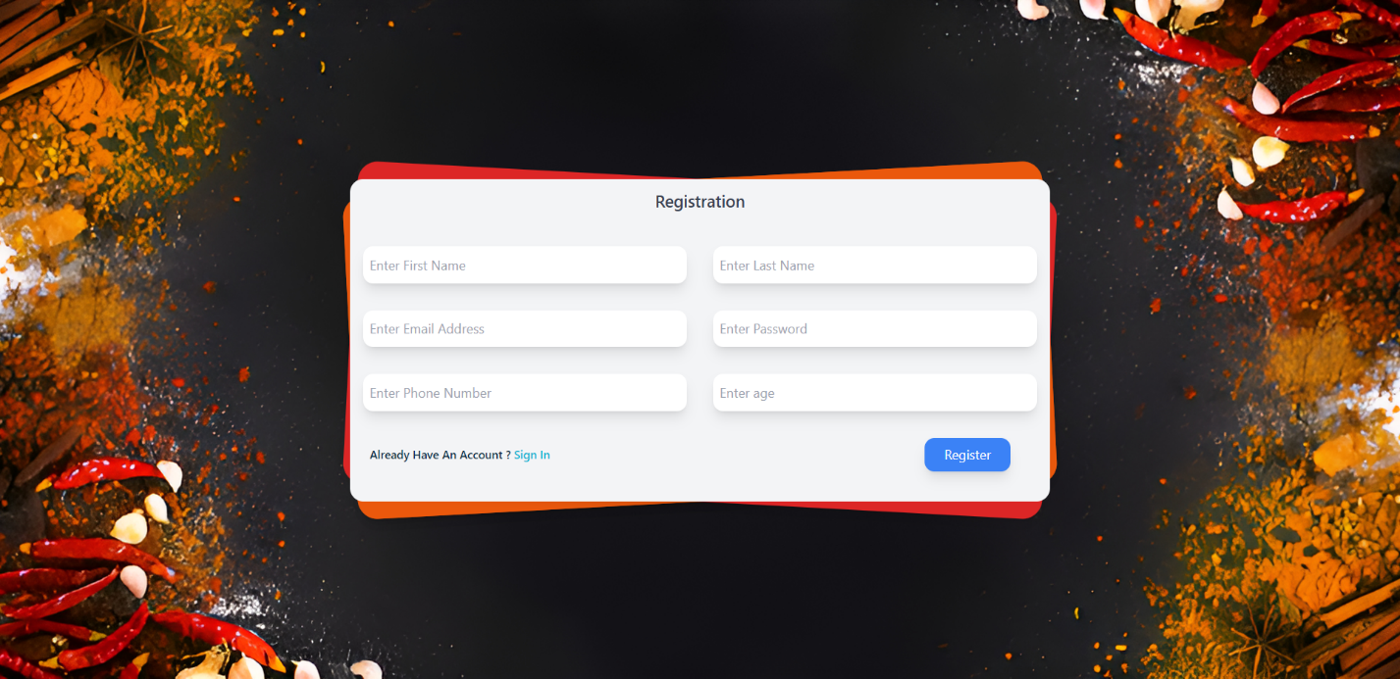

Fig.1 Registration page

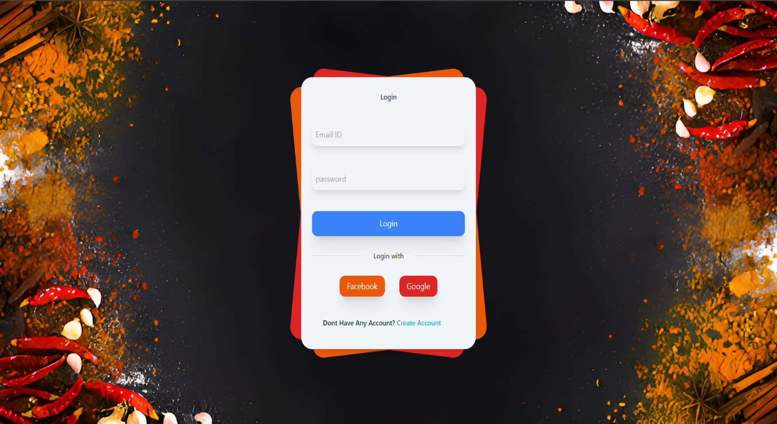

Fig.2 Login Page

This is the Login page of swaad-saathi where you will find the login with Facebook and Gmail

**Step 2:**

**Home**

After logging in or signing up on Swaad Saathi, users are seamlessly redirected to the Home Page, where a plethora of enticing features awaits. At first glance, users are greeted with a curated selection of Top Rated Restaurants, meticulously chosen based on customer feedback and ratings. This personalized touch not only guides users towards exceptional dining experiences but also fosters a sense of trust and reliability in the platform. As users navigate through the Home Page, they are presented with an array of Food Categories, catering to diverse culinary preferences and cravings. From indulgent desserts to savory delights, each category beckons exploration and discovery, enticing users to embark on a culinary journey tailored to their tastes. Furthermore, Swaad Saathi prioritizes user convenience by seamlessly integrating a Favourites section, allowing users to bookmark and revisit beloved eateries with ease. Whether it's a cozy café for morning coffee or a fine dining establishment for special occasions, users can effortlessly access their preferred dining destinations at the click of a button. Additionally, Swaad Saathi goes the extra mile to enhance user experience by showcasing Top Places Near You, leveraging geolocation technology to surface nearby culinary gems. This thoughtful feature not only simplifies decision-making but also encourages users to explore hidden culinary gems in their vicinity, transforming every meal into a delightful adventure. In essence, Swaad Saathi's Home Page serves as a gateway to a world of culinary delights, offering a seamless and personalized dining experience that caters to the diverse tastes and preferences of its users.

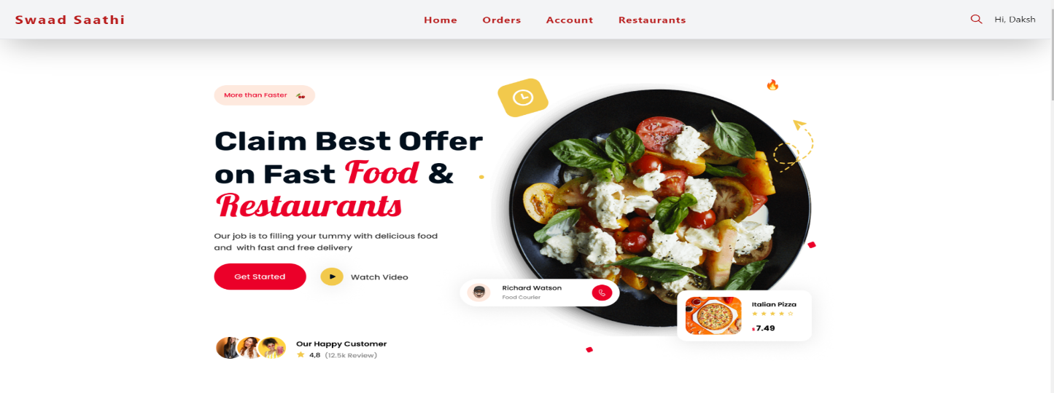

Fig.3 Home

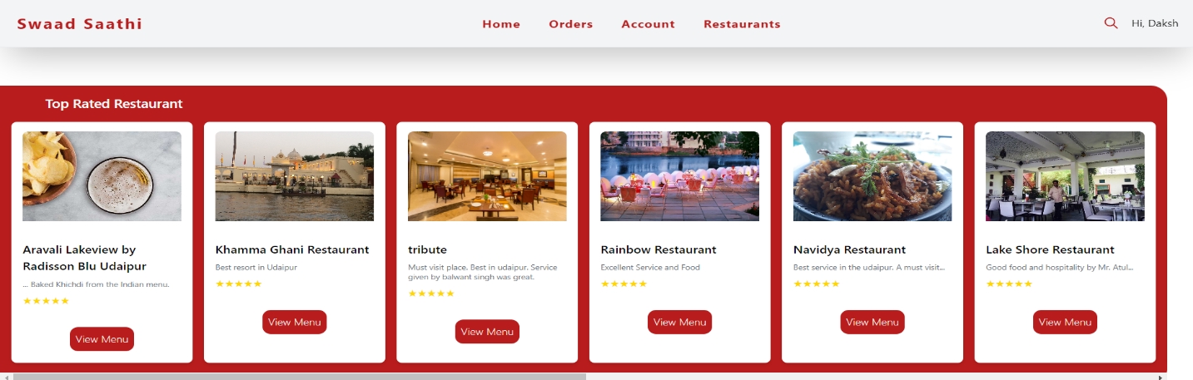

Fig.4 Top rated

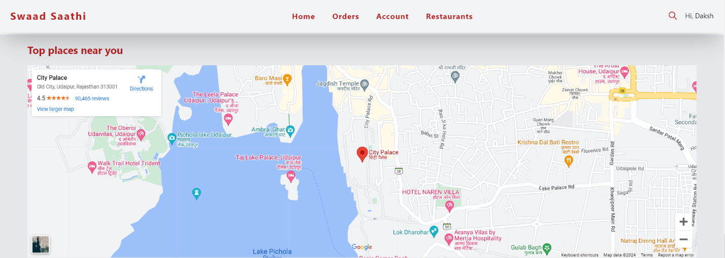

Fig.5 Near You

**Step 3 :**

**Restaurants**

The "Restaurants" module within Swaad Saathi offers users a seamless journey from browsing to placing orders, culminating in a smooth and efficient checkout process. Upon selecting the "Restaurants" option, users are presented with a comprehensive list of dining establishments available on the platform. Each restaurant listing provides essential details, enticing users to explore their menus and offerings.

Upon choosing a restaurant, users are seamlessly transitioned to the ordering process. With a simple click on the "Order Now" button, users initiate the ordering flow, signaling their intent to place an order. This action redirects users to their personal Orders page, where they can review and manage their active orders.

Within the Orders page, users are empowered to take further action by adding items to their cart. With a click on the "Add to Cart" button next to desired items, users curate their order, customizing it to their preferences. Once satisfied with their selection, users proceed to the next step by clicking on the "Go to Cart" button.

Upon entering the Cart page, users are presented with a summary of their order, including selected items and quantities. From here, users can review their order and make any necessary adjustments before proceeding to checkout. Clicking on the "Proceed to Checkout" button initiates the final step in the ordering process.

The Checkout page offers users a streamlined interface to complete their purchase. Powered by Stripe, a trusted and secure payment gateway, users can confidently proceed with their transaction. After entering payment details and confirming the order details, users finalize their purchase by clicking on the "Pay" button.

With the click of a button, users successfully place their order, marking the culmination of a seamless and efficient ordering experience within Swaad Saathi. From browsing restaurants to completing the checkout process, Swaad Saathi ensures a user-centric approach, providing a hassle-free platform for users to indulge in their culinary cravings.

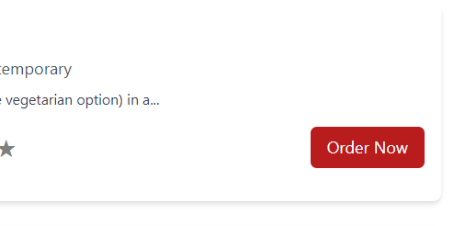

Fig.6 Order Now

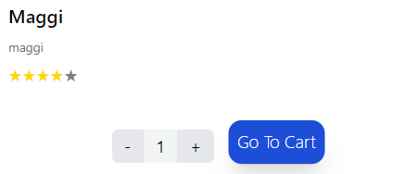

Fig.7 Go To Cart

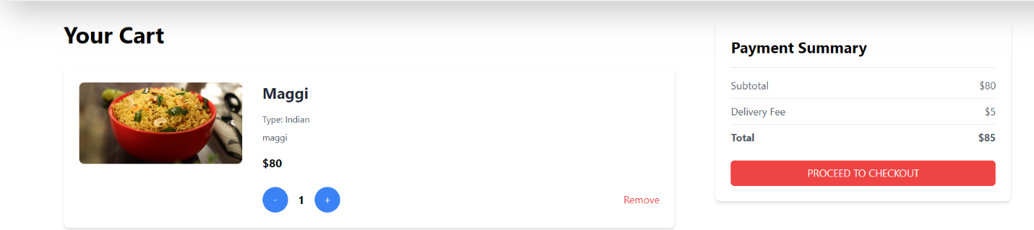

Fig.8 Proceed To Checkout

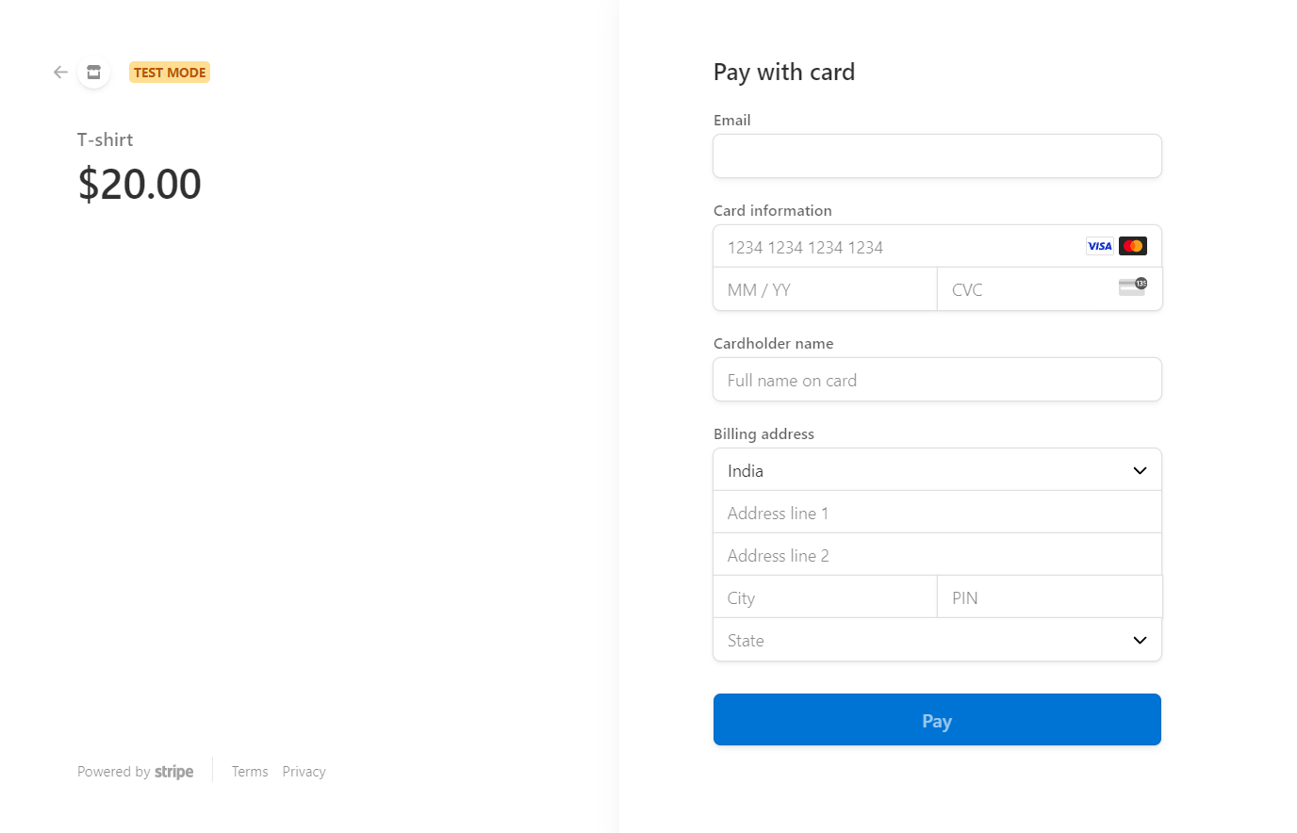

Fig.*9* Pay Now

**Step 4:**

**Profile**

The "Profile" feature within Swaad-Saathi provides users with a convenient and centralized hub to access their personal information and account details. Upon clicking on the "Profile" option, users are presented with an intuitive interface displaying their basic information, including email address and phone number.

1. Accessing Personal Information:

The Profile section serves as a one-stop destination for users to access essential details associated with their account. By clicking on this option, users gain instant access to their basic information without navigating through multiple pages or menus. This streamlined approach enhances user convenience and accessibility, allowing users to manage their account effortlessly.

2. Displaying Basic Information:

Within the Profile interface, users can view pertinent details such as their registered email address and phone number. These pieces of information serve as crucial identifiers and contact points, enabling seamless communication between Swaad-Saathi and its users. By providing transparent access to their basic information, Swaad-Saathi fosters trust and accountability, reinforcing its commitment to user privacy and security.

3. User-Friendly Interface:

The Profile section features a user-friendly interface designed with simplicity and clarity in mind. Information is presented in a concise and organized manner, ensuring ease of comprehension for users of all technical backgrounds. Clear labels and intuitive navigation elements guide users through the interface, facilitating a seamless user experience.

4. Enhanced Customization and Control:

In addition to displaying basic information, the Profile section may offer users options for customization and control over their account settings. This may include the ability to update or edit personal details, manage communication preferences, and configure account security settings. By empowering users with control over their account settings, Swaad-Saathi prioritizes user autonomy and satisfaction, further enhancing the platform's appeal and usability.

Overall, the Profile feature within Swaad-Saathi streamlines the user experience by providing easy access to essential account details. By prioritizing simplicity, transparency, and user control, Swaad-Saathi ensures that users can manage their accounts effectively while enjoying a seamless and personalized dining experience.

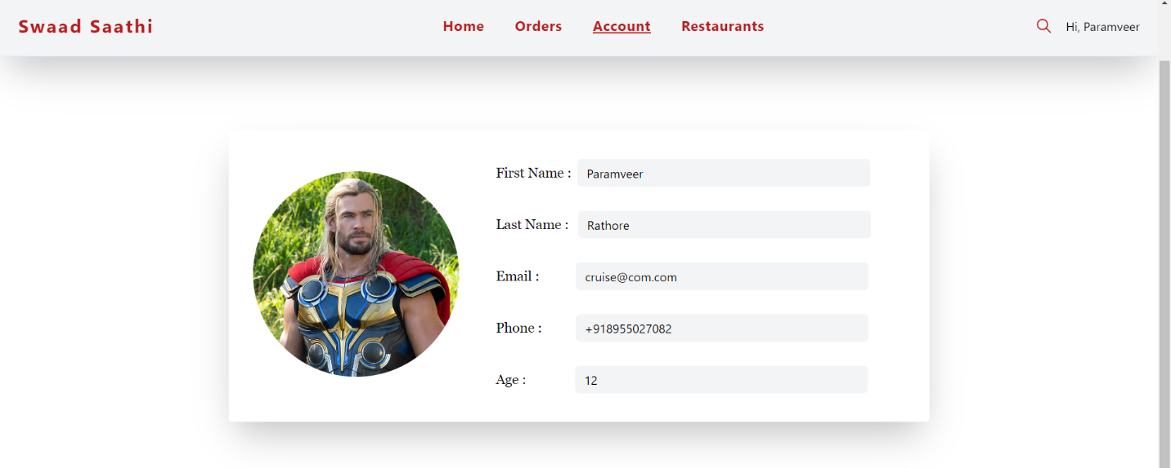

Fig.10 Account

**Step 5 :**

**Orders**

The "Orders" section within Swaad-Saathi offers users a comprehensive overview of their order history, providing valuable insights into past transactions and dining experiences. This feature serves as a centralized repository where users can conveniently track and manage their order history, fostering transparency and accountability in their interactions with the platform.

**1. Accessing Order History:**

Upon accessing the "Orders" section, users are presented with a chronological list of their past orders. This streamlined interface allows users to quickly navigate through their order history, facilitating efficient retrieval of relevant information.

**2. Detailed Order Information:**

Each entry in the order history provides detailed information about the corresponding transaction, including the date and time of the order, the restaurant name, ordered items, total cost, and order status. By presenting this information in a structured format, Swaad-Saathi enables users to review their past dining experiences with ease.

**3. Tracking Order Status:**

Users can easily monitor the status of their orders within the order history interface. Whether the order is confirmed, in progress, or completed, users receive real-time updates on the progress of their transactions. This transparency enhances user confidence and satisfaction, ensuring a seamless and reliable ordering experience.

**4. Reordering Convenience:**

To streamline the ordering process, Swaad-Saathi may offer users the option to reorder items from their order history with a single click. By leveraging past order data, users can effortlessly replicate previous dining experiences, saving time and effort.

**5. Order Details and Receipts:**

Users can access detailed receipts for each past order, providing a breakdown of items ordered, pricing information, and payment method used. This transparency enhances trust and accountability, allowing users to verify the accuracy of their transactions.

**6. Personalization and Recommendations:**

Swaad-Saathi may leverage order history data to personalize user experiences and provide tailored recommendations. By analyzing past order patterns and preferences, the platform can suggest relevant restaurants, menu items, and promotions that align with each user's tastes and preferences.

**7. User-Friendly Interface:**

The order history interface features a user-friendly design with intuitive navigation elements and clear labeling. This ensures that users of all technical proficiencies can easily access and interact with their order history, fostering a positive user experience.

In summary, the "Orders" section within Swaad-Saathi empowers users with convenient access to their order history, enhancing transparency, and facilitating informed decision-making. By prioritizing usability, transparency, and personalization, Swaad-Saathi reinforces its commitment to delivering exceptional dining experiences to its users.

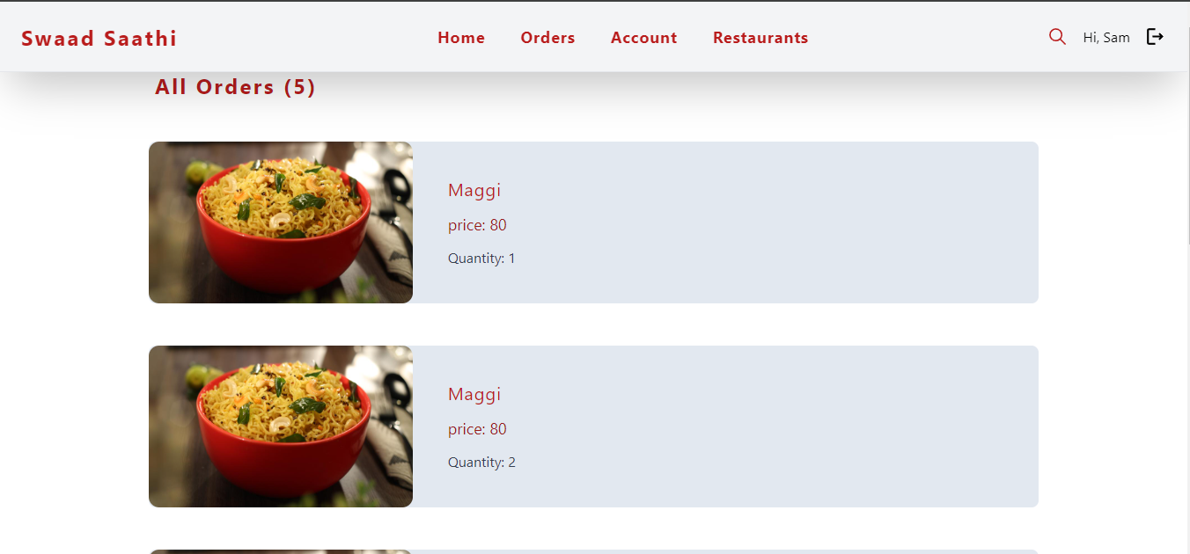

Fig.11 Order History

**Step 6 :**

**Admin Panel**

The Admin Panel serves as the central control hub for managing various aspects of the Swaad-Saathi Food Delivery System. With intuitive interfaces and streamlined functionalities, administrators can efficiently oversee restaurant and menu management, monitor orders, and ensure smooth operations.

**1. Add Restaurant:**

The "Add Restaurant" feature empowers administrators to expand the platform's culinary offerings by seamlessly integrating new dining establishments. Administrators can effortlessly input essential restaurant details, including the restaurant name, description, type, rating, and city. Upon completing the required fields, administrators can click the "Add" button to initiate the restaurant addition process. This feature streamlines restaurant onboarding, enabling swift expansion and diversification of the platform's offerings.

**2. Add Items:**

The "Add Items" functionality enables administrators to enrich the platform's menu offerings with enticing dishes and beverages. Administrators can upload captivating item images, specify item names, set item prices, provide detailed descriptions, and assign item types and ratings. By meticulously curating the platform's menu, administrators enhance user engagement and satisfaction, catering to diverse culinary preferences. Upon inputting item details, administrators can click the "Add" button to seamlessly incorporate new menu items into the platform's offerings.

**3. Orders Management:**

The Orders section within the Admin Panel provides administrators with comprehensive insights into order activity, facilitating efficient order management and fulfillment. Administrators can monitor incoming orders, track order statuses, and oversee order fulfillment processes in real-time. By leveraging intuitive interfaces and informative visualizations, administrators can effectively prioritize and manage orders, ensuring timely delivery and customer satisfaction.

**4. Dashboard Overview:**

The Admin Panel dashboard serves as a comprehensive tool that aggregates and presents key metrics and insights essential for effective platform management and strategic decision-making. This dashboard provides administrators with a centralized view of the Swaad-Saathi Food Delivery System's performance, enabling them to monitor various aspects of the platform's operations in real-time.

**Holistic Overview:**

The dashboard offers administrators a holistic view of the platform's performance by consolidating data from different areas of the system. It presents a unified snapshot of critical metrics and performance indicators, allowing administrators to assess the overall health and effectiveness of the platform at a glance.

**Key Metrics:**

The dashboard provides access to vital statistics that offer insights into various aspects of platform activity. These metrics typically include:

- Total Orders: The number of orders placed on the platform within a specific time frame, indicating user engagement and demand for the services offered.

- Revenue Generated: The total monetary value generated from orders placed on the platform, reflecting the platform's financial performance and revenue streams.

- Customer Feedback Ratings: Aggregate ratings and feedback provided by users on their dining experiences, helping administrators gauge customer satisfaction levels and identify areas for improvement.

- Restaurant Performance Indicators: Metrics related to individual restaurant performance, such as order volume, customer ratings, and revenue contribution, allowing administrators to assess the effectiveness of restaurant partnerships and optimize offerings.

**Strategic Decision-Making:**

By leveraging the insights provided by the dashboard, administrators can make informed decisions to drive platform growth and success. These decisions may include:

- Identifying Trends: By analyzing trends in order volume, revenue, and customer feedback, administrators can identify emerging patterns and preferences within the user base. This information enables them to anticipate market trends and adjust platform strategies accordingly.

- Optimizing Operations: Administrators can use dashboard data to identify bottlenecks, inefficiencies, or areas of underperformance within the platform's operations. By addressing these issues, administrators can streamline processes, improve service quality, and enhance overall user experience.

- Driving Business Growth: Insights gleaned from the dashboard can inform strategic initiatives aimed at expanding the platform's user base, increasing revenue streams, and fostering long-term sustainability. Administrators can develop targeted marketing campaigns, forge strategic partnerships, and introduce innovative features based on data-driven insights.

**Continuous Improvement:**

The Admin Panel dashboard facilitates a culture of continuous improvement by providing administrators with the tools and information needed to monitor performance metrics and track progress over time. Administrators can set benchmarks, establish goals, and measure outcomes against predefined targets, driving ongoing optimization and refinement of platform operations.

**5. User Management:**

The User Management feature enables administrators to efficiently manage user accounts, ensuring compliance with platform policies and regulations. Administrators can view user profiles, update account information, and enforce security measures as needed. By maintaining a secure and transparent user management system, administrators uphold user trust and confidence in the Swaad-Saathi platform.

**6. Reporting and Analytics:**

The Admin Panel includes robust reporting and analytics capabilities, empowering administrators to gain actionable insights into platform performance and user behavior. Administrators can generate customized reports, analyze sales trends, and identify opportunities for optimization. By leveraging data-driven decision-making, administrators can enhance operational efficiency, drive revenue growth, and improve user satisfaction.

**Summary:**

In conclusion, the Admin Panel of the Swaad-Saathi Food Delivery System serves as a critical component in managing platform operations and ensuring a seamless user experience. Through intuitive interfaces, comprehensive functionalities, and data-driven insights, administrators can effectively oversee restaurant and menu management, monitor order activity, and drive business growth. By prioritizing efficiency, transparency, and user satisfaction, the Admin Panel empowers administrators to unlock the full potential of the Swaad-Saathi platform and deliver exceptional culinary experiences to users.

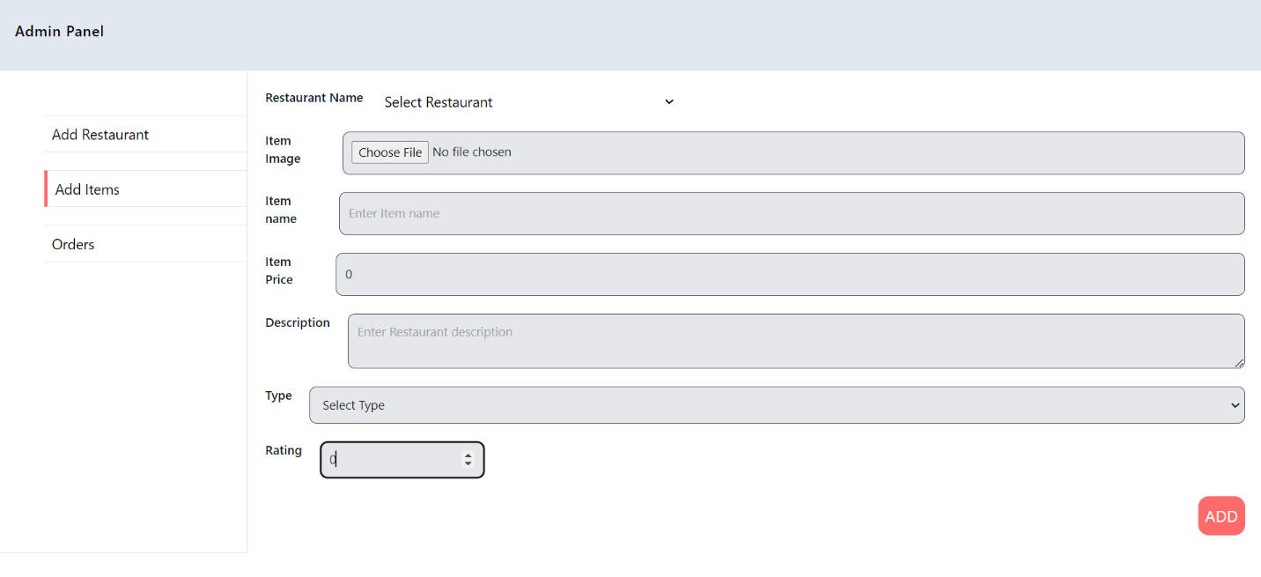

Fig.12 Add Items

This is the Add items Panel and in this you have Some Fields to fill as explained

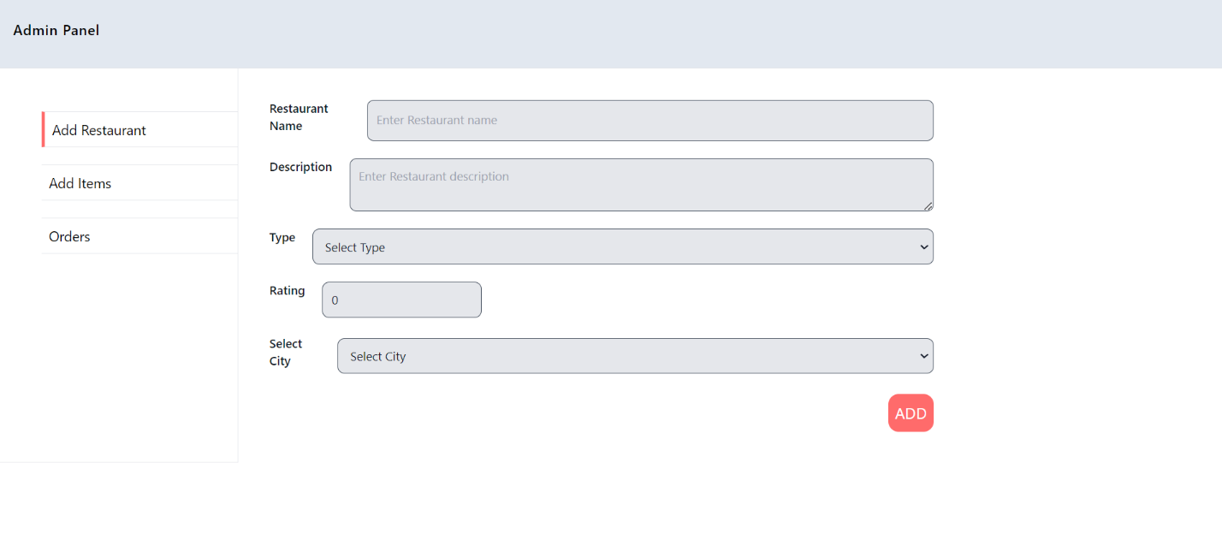

Fig.13 Add Restaurant

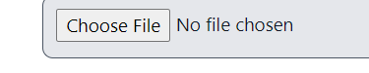

Fig.14 Choose File

**Conclusion:**

In conclusion, the Swaad-Saathi Food Delivery System represents a significant advancement in the realm of online food ordering platforms. Through meticulous planning, thoughtful design, and strategic implementation, the project has successfully addressed the inherent challenges and limitations present in traditional food delivery systems.

The project's emphasis on user-centric design, personalized experiences, and seamless functionality has resulted in a platform that not only meets but exceeds user expectations. By leveraging cutting-edge technologies such as Next.js, TypeORM, Tailwind CSS, and Stripe, Swaad-Saathi delivers a modern and intuitive user interface while ensuring robust backend functionality and security.

The implementation of features such as registration and login, home page with curated restaurant listings, streamlined ordering process, profile management, and order history tracking demonstrates a deep understanding of user needs and preferences. These features collectively contribute to a frictionless user experience, enhancing user satisfaction and loyalty.

Moreover, the project's future scope highlights a commitment to continuous improvement and innovation. With plans for global expansion and integration with emerging technologies such as AI and machine learning, Swaad-Saathi aims to stay at the forefront of the food delivery industry, catering to diverse markets and evolving consumer preferences.

In essence, the Swaad-Saathi Food Delivery System not only simplifies the process of ordering food but also elevates it to a personalized and enriching experience. As technology continues to advance and consumer expectations evolve, Swaad-Saathi stands poised to adapt and thrive, offering users a culinary journey filled with flavor, convenience, and delight.

**Future Scope:**

The future scope of Swaad-Saathi holds immense potential for growth and innovation, with a strategic focus on global expansion and integration with emerging technologies.

**1. Global Expansion:**

Swaad-Saathi's successful implementation lays the foundation for ambitious global expansion endeavors. By leveraging the platform's robust infrastructure and proven business model, Swaad-Saathi can venture into diverse markets worldwide. This expansion presents an opportunity to introduce the platform's curated selection of restaurants and culinary experiences to a global audience. Each market offers unique culinary preferences and cultural nuances, necessitating localized strategies to resonate with users effectively. Through meticulous market research and strategic partnerships, Swaad-Saathi aims to establish a strong foothold in key regions, fostering a global community of food enthusiasts united by a shared passion for exceptional dining experiences.

**2. Integration with Emerging Technologies:**

To stay at the forefront of innovation, Swaad-Saathi explores the integration of cutting-edge technologies such as Artificial Intelligence (AI) and machine learning. These technologies hold immense potential to revolutionize the platform's user experience, particularly in the realm of personalized recommendations. By analyzing user behavior, preferences, and past orders, AI algorithms can generate tailored recommendations that resonate with individual users. These recommendations extend beyond restaurant selections to encompass menu items, special offers, and promotions, creating a hyper-personalized dining journey for each user. Moreover, machine learning algorithms continuously refine their recommendations based on real-time data, ensuring relevance and accuracy over time. By embracing AI and machine learning, Swaad-Saathi reaffirms its commitment to innovation and excellence, cementing its position as a leader in the online food delivery industry.

In summary, Swaad-Saathi's future scope encompasses ambitious endeavors towards global expansion and integration with emerging technologies. By embracing these opportunities, Swaad-Saathi aims to transcend geographical boundaries, deliver unparalleled dining experiences, and pioneer innovation in the ever-evolving landscape of food technology.

**BIBLIOGRAPHY:**

1. NextJs: <https://nextjs.org/docs>
2. TypeORM : <https://typeorm.io/>
3. Tailwind CSS : <https://tailwindcss.com/docs/installation>
4. SupaBase : <https://supabase.com/docs/guides/database/overview>
5. VS Code : <https://code.visualstudio.com/docs>
6. Stripe : <https://docs.stripe.com/stripe-js/react>